Post Campaign Media Wrap-Up
Publicize Your Good News!

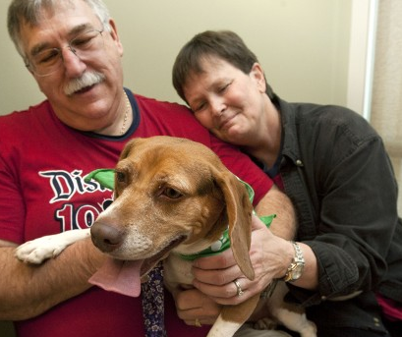

Media attention for your organization doesn’t have to come to an end at the conclusion of your adoption event. The final week of the Blue Buffalo Home 4 the Holidays campaign is yet another opportunity to shine a media spotlight on the amazing successes your rescue facility has seen over the past three months!

Follow up with a Post-Campaign Press Release! Once numbers have been tallied, incorporate your organization’s grand total of orphan animals saved during the campaign, as well as the total number of orphan animals saved globally (found on www.home4theholidays.org), in a post-campaign press release. Celebrate the success of the program by providing adoption stats and photos or short clips of video footage (IPhone video is fine) of your favorite adoption stories.
(A post-campaign press release sample can be found in the “Template Materials” section of the How-To Guide.)

Great Tips!
- If you have a particularly touching adoption story, be sure to include it as a main focus in your post-campaign press release. Give moving details of the orphan’s past life, how it came to your facility and what type of family took it home. (You may want to identify these stories in advance so that you can ask the adopting family if they are willing to be interviewed by TV media at the end of the campaign. Be sure to have them sign a photo release, as well!) ALWAYS include great photos or video of this pet.

- If a high-profile adopter takes home one of your orphan pets, be sure to include this adopter as a main focus in your post-campaign press release. (This may include an athlete, a local politician, a local news anchor, or even a high-profile chef from a local restaurant.) It is imperative you receive permission from this adopter before you include their story in your press release. Have the adopter sign a photo release too! BE SURE to include great photos or video of your adopter taking home their new pet.

